Please explore and start to build a crawler for India fertilizer information per district.

Starting website is: <https://inputsurvey.dacnet.nic.in/districttables.aspx>

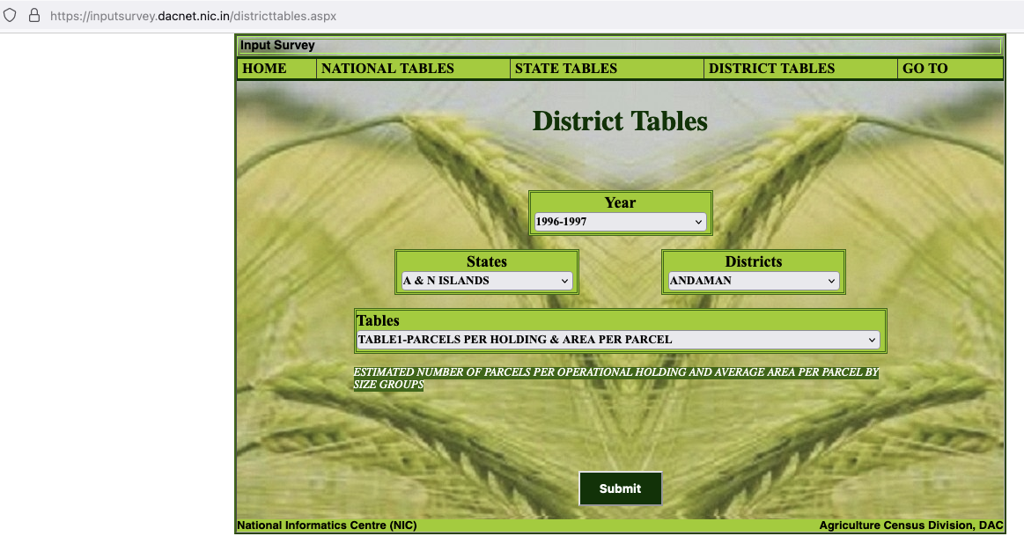

Year: Let’s start with the 2016-2017 and work backward in time in 2024

State: I will use the example of: Punjab

District: I will use the example of: Amritsar (It is quite common it seems that data will be absent for 2016-2017 but will be present in 2011-2012).

In the Tables section, I am really interested now for TABLE 4A-USAGE OF DIFFERENT FERTILIZERS FOR DIFFERENT CROPS

When we select this option for the table, 2 subtables pop up: Crops & Fertilizers

(I would like us to get the information for all the crops and all the Fertilizers)

In the example I choose PADDY (for the crop) and UREA (Fertilizers). In both China and India too much application of Urea is taking place which leads to soil acidification, eutrophication of waters, and nitrous oxide emissions. Even air pollution is being impacted from atmospheric reaction.

Like the Tehsil crawler, I want to get the raw csv table downloaded. I have given the downloaded csv from the example choices.

I have downloaded when the crop was changed to wheat and maize as well

Please make the code sufficiently dynamic so that if we want to run it on other \*Tables\* like Table 5H-USAGE OF PESTICIDES FOR DIFFERENT CROPS

Etc.

We can do that.

Thanks